**Material Selection in XR**

**Testing plan for interactive prototype 2**

This project is an Odoo app enhanced with XR technology to transform how users explore and assemble materials. It allows users to interact with virtual materials, manipulate and interact with materials. This experience aims to make material selection more engaging, efficient, and accessible, especially for education and workplace training.

**Testing Objective**

Assumptions

* Users already know how to move, pick up, drop, and rotate materials on screen.
* Users can relate to the on‑screen UI, understanding that it represents interaction with the closest object.
* Users understand the concept of validation feedback in XR environments.
* Users recognize the concept of assembling interlocking materials based on a visual reference.

Unknowns

* Do users find the object manipulation controls (pick, drop, rotate, move) intuitive for assembly?
* How do users respond to visual validation cues (positive/negative highlights)?
* Does validation feedback improve assembly accuracy, speed, or confidence?
* How does lacking colour or orientation cues affect user engagement and performance?

Test Objectives

This test aims to discover:

* Whether users can intuitively assemble blocks to replicate a pictured table in XR.
* How validation feedback impacts accuracy and user strategy.
* If users engage playfully and curiously with the novel interlocking material.
* Differences in performance and experience when assembly tasks have distinct visual cues.

**Testing Methodologies**

This testing plan will use qualitative methods with an applied think‑aloud protocol, encouraging participants to verbalize thoughts during assembly tasks. It employs A/B testing: participants complete two tasks—assembling tables based on two reference images, one with colour and orientation cues, one without. Timing, error rate, and user feedback are recorded.

Prototype description/requirements  
The prototype is built using Unity featuring:

* Grabbable, moveable, rotatable interlocking blocks with snap interactions.
* Base plate with snap zones for multidirectional upward and sideways assembly.
* Two reference images of tables for assembly—Image 1 with colour and orientation cues, Image 2 without.
* Visual validation feedback (green/red highlights) during Task 2 for correct or incorrect placement.

Tasks

* Task 1: Assemble the table from Image 1 (with colour/orientation cues), no validation feedback.
* Task 2: Assemble table from Image 2 (without cues), with validation feedback active.

Data collection method

* To observe and record User behaviours and thought processes (think-aloud)
* Timing to task completion
* Number and type of errors or misplacements
* Post-task reflections captured through interviews
* All sessions will be video and audio recorded for detailed analysis.

Testing Setup

* Fully functioning Unity XR prototype on Meta Quest headset
* Quiet, comfortable testing environment with safe movement space
* Reference images displayed clearly to participants
* Recording equipment configured for screen and audio capture
* Consent forms and briefing materials prepared

Testing process: (Estimated 5 minutes)

Welcome and Introduction

* Greet participants, explain test is prototype-focused, encourage thinking aloud
* Obtain consent, fit the headset, teach basic interactions if needed
* Task 1: Assemble table with cues, no validation, observe and record

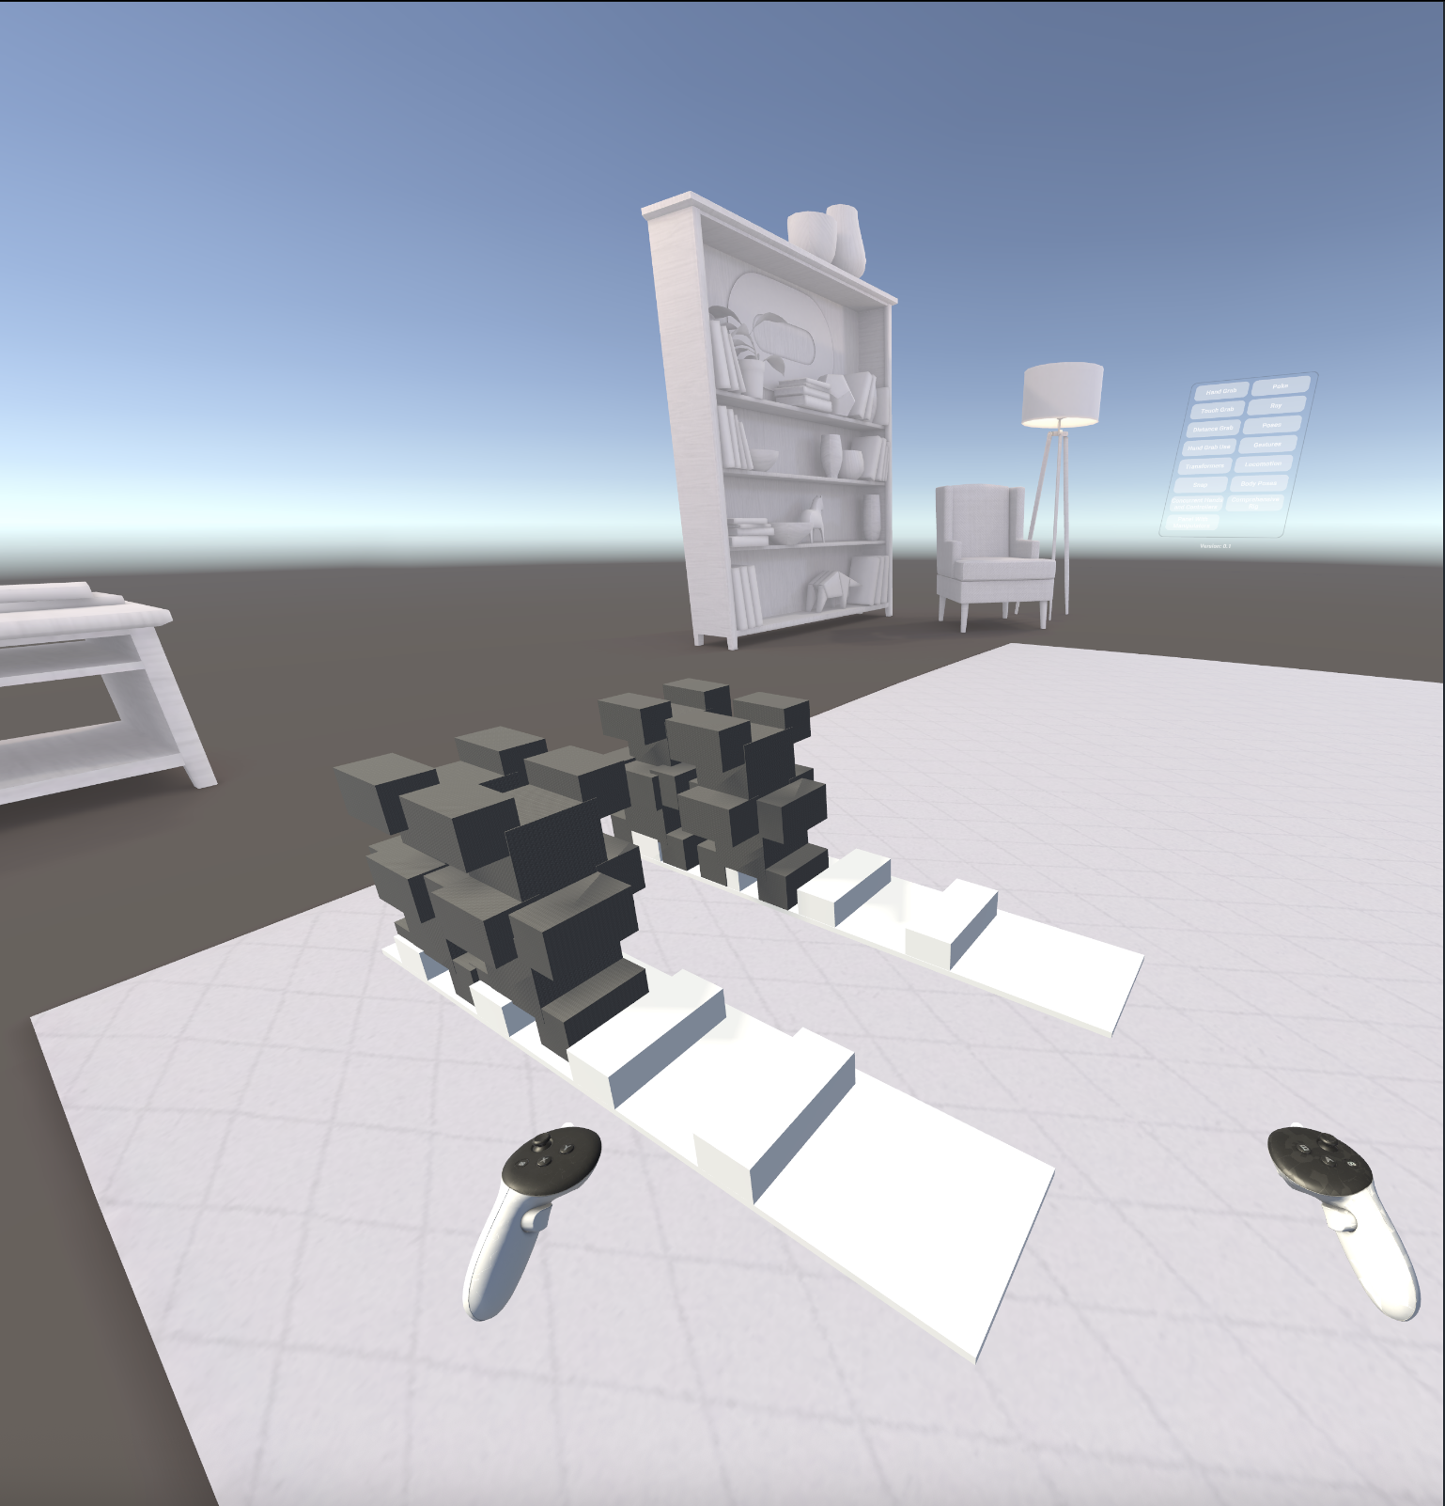

* Task 2: Assemble table without cues, validation active, observe and record

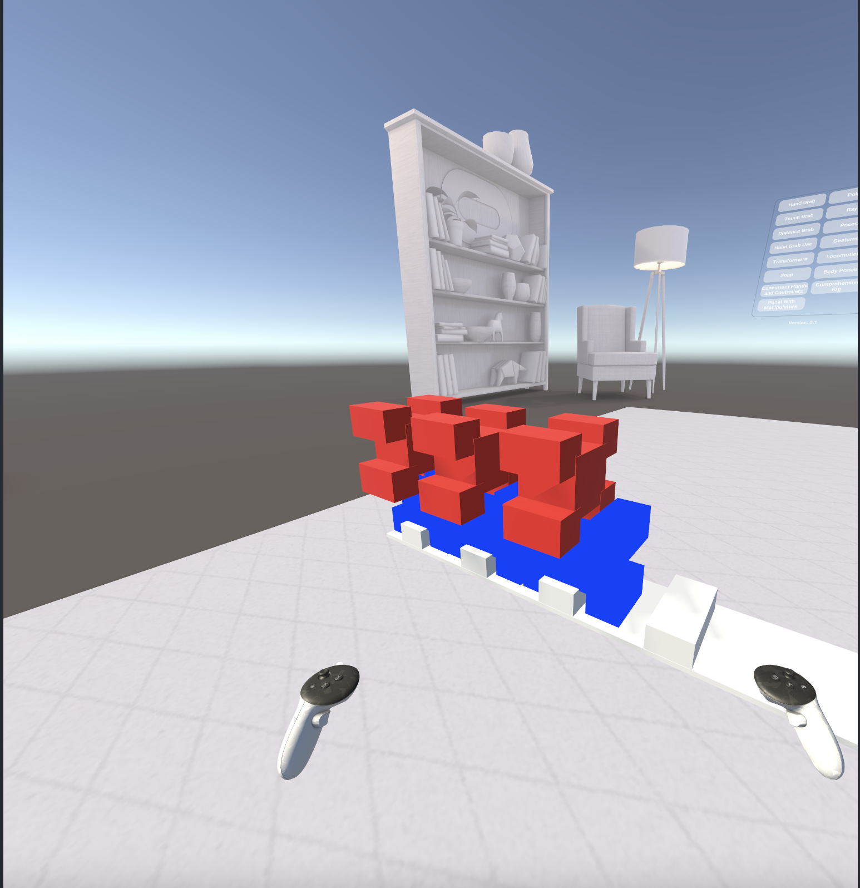

* Ask about interaction ease, use of cues and validation, engagement, learning or discovery

**Post-Task Questions**

1. Were you able to complete the assembly successfully?
2. Which task felt easier or more challenging, and why?
3. How helpful were the colour and orientation cues (if present)?
4. Did the validation feedback help you know if your placements were correct?
5. How intuitive did the grabbing and snapping controls feel?
6. Did the task make you feel curious or encourage experimentation?
7. What, if anything, would improve the experience for you?

**NASA TLX Questionnaire**

Please rate from 1 (very low) to 20 (very high):

1. Mental Demand
2. Physical Demand
3. Temporal Demand
4. Performance (1 = perfect, 20 = failure)
5. Effort
6. Frustration